The Power of Online Resume Makers: Benefits for Job Seekers
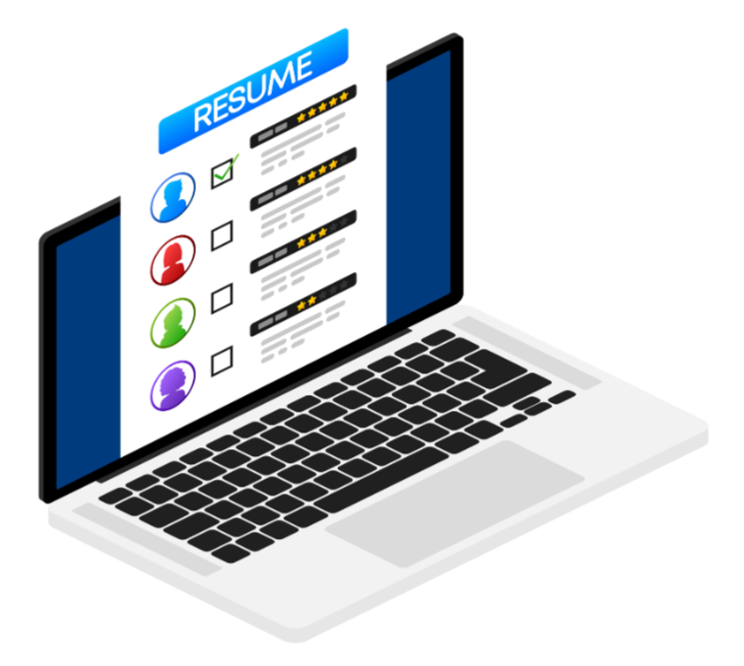

A well-crafted resume can make or break your chances of landing on a job interview. It can determine whether you move on to the next stage of the hiring process or end up in the reject pile.
This highlights the importance of creating a resume that makes a lasting impression on the recruiter or the hiring manager. As a job seeker, you would want your resume to be the best & using a resume maker can provide several opportunities for the same.
This blog will take you through the advantages of using a Resume Builder Online Tools & will then introduce to you an online resume building tool that can help you craft the best resume & reach your career goals.

Advantages of using a Resume Maker:
Professional Templates
First impressions count, & a resume maker ensures that your resume looks professional & aesthetically pleasing. They provide you with a fresh set of templates that help you showcase a consistent look throughout your resume. A well-designed resume not only catches the eye but also reflects your attention to detail & commitment to professionalism. Therefore, taking the help of a resume maker can guarantee you a clean resume which might be challenging in a DIY approach.

Saves Time
Creating a resume from scratch can be time-consuming. A resume maker allows you to speed up this process by providing structured templates that organize your information effectively. Instead of spending hours formatting & rearranging text, you can focus on tailoring the content to your career goals. This efficiency means you can apply to more jobs in less time.

Easily Customizable
Resume Builders allow you to experiment with colors, fonts & formats as per your industry standards. This customization allows you to highlight your strengths & achievements in a way that aligns with the job you are applying for. It also ensures that the content in your resume is unique to begin with.

Reduction of Errors
Errors in your resume can undermine your professionalism & hurt your chances of landing an interview. Resume makers often include built-in tools for spell-checking & grammar correction, which help minimize mistakes. Additionally, the pre-formatted nature of these tools reduces the risk of misalignment or inconsistent styling, ensuring a clean & error-free resume.

ATS Optimization
Many companies use Applicant Tracking Systems (ATS) to screen resumes before they even reach human eyes. Resume makers often include features that optimize your resume for ATS by ensuring it includes relevant keywords & is formatted in a way that is easily readable by these systems. This can increase the chances of your resume getting past initial screenings.

Ease of Use
Creating a resume from scratch can be a daunting task, especially if you are not familiar with resume formatting. Resume makers are designed to simplify this process. They offer user-friendly interfaces & guided workflows, making it easy to input your information & see it transformed into a polished document.

Guides Content Creation
Most resume makers come with built-in guidance & tips for each section of your resume. They often provide prompts & examples to help you articulate your skills, experience, & accomplishments effectively. This guidance is especially beneficial for those who are new to resume writing or who are looking to update an outdated resume.

Ease of Updating
Your resume is not a one-time document; it evolves with your career. Online Resume makers make it easy to update your resume as you gain new experiences & skills. You can quickly add new accomplishments, modify existing content, & reformat your resume to reflect your latest career developments.

Export Options Available
Most resume makers allow you to export your resume in various formats, such as PDF, Word, or even directly to job application platforms. This versatility ensures that you can submit your resume in the format preferred by the employer or application system.

Cost- Effective
While there are free resume makers available, many offer premium features at a relatively low cost. Investing in a paid version can provide access to more advanced templates, additional customization options, & enhanced ATS compatibility. This small investment can significantly boost the quality of your resume along with your job prospects.

PaintMinds – An Online Resume Maker
PaintMinds offers you the best professional resume templates that you can choose from to build your ATS-compliant resume. Pick your template & process the payment along with providing data inputs to the team. Your resume will be built by a team of experts who have worked on 100+ resumes & professional profiles.
The team will then start working on your new resume based on your input. Also, receive personalized guidance from our experts into how you can get selected for interviews & boost your chances of getting your dream job! Visit the PaintMinds website right now.

Keywords: Online Resume Maker | free resume makers | Resume Builder Online | resume building | Cost-Effective
Focus: Online Resume Maker
Meta Tag: Top 10 Advantages of Using an Online Resume Maker for Job Seekers
Meta Description: An online resume maker allows you several benefits like time efficiency & reduction of errors. But how can you choose the best one out of the various options available. Read to know more.
Title Tag: Why Job Seekers Should Embrace Online Resume Makers: 10 Key Benefits | PaintMinds

